Name | Debjit Ghosal
UID no. | 2023300065
Experiment No. | Experiment 1

AIM: | Use the formatted input/output statements, operators and expressions of C language
Program 1
PROBLEM STATEMENT : | Write a C program to input 2 numbers. Perform addition, subtraction, multiplication, division and modulus and display output.
ALGORITHM: | Step 1: Start  Step2:Take input as a and b  Step3:Read the value of a and b  Step 4:Perform addition, subtraction, multiplication and division  Step 5: Stop
FLOWCHART: | 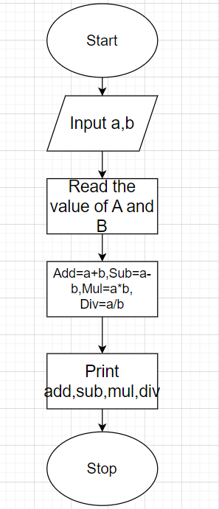
PROGRAM: | #include<stdio.h>  int main()  {  int a,b;  printf("Enter Value of A and B :");  scanf("%d %d",&a,&b);  printf("a+b=%d \n",a+b);  printf("ab=%d \n",a-b);  printf("a*b=%d \n",a*b);  printf("a/b=%f",(float)a/b);  return 0;
RESULT: 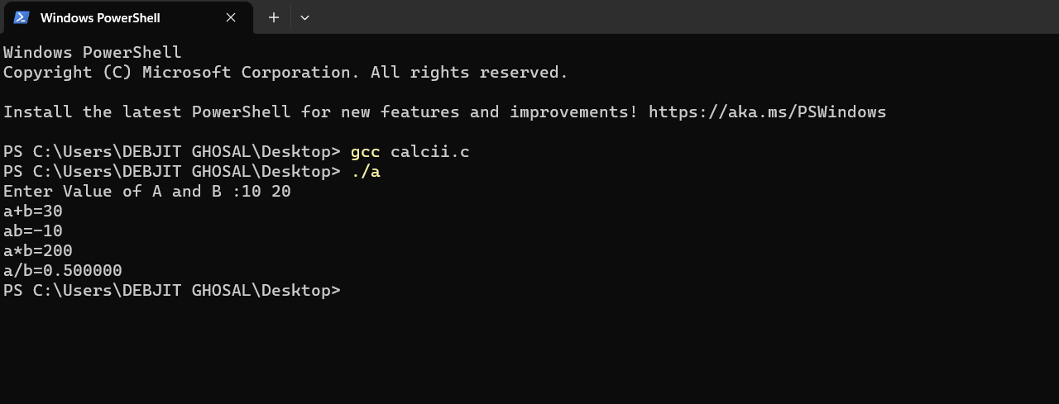
Program 2
PROBLEM STATEMENT : | WAP to Convert Celsius to Fahrenheit. Answer should be rounded upto 2 decimal places.
ALGORITHM: | Step 1: Start  Step 2: Read celcius  Step 3: Read F= (cel*9/5)+32  Step 4: Display the temperature in Fahrenheit  Step5 :Stop
FLOWCHART: | 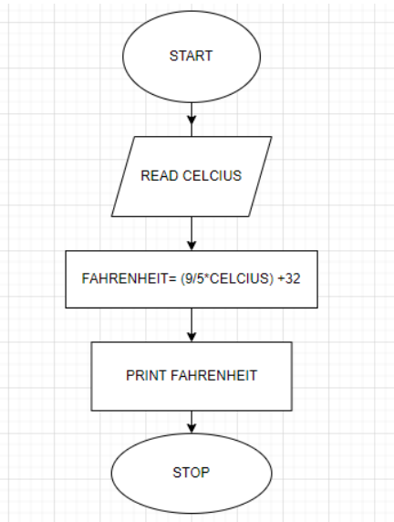
PROGRAM: | #include <stdio.h>  int main()  {  float cel,faren;  printf("Enter temerature in Celcius : ");  scanf("%f",&cel);  faren=(cel*9/5)+32;  printf("The Temperature in Fahrenheit is %.2f",faren);  return 0;  }
RESULT: 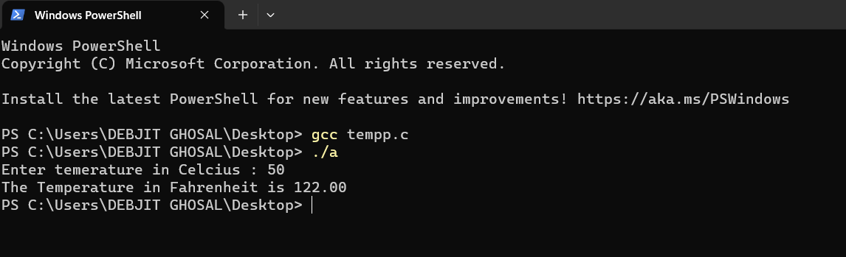
Program 3
PROBLEM STATEMENT: | WAP to Convert Foot to Meter. Answer should be rounded upto 3 decimal places.
ALGORITHM: | Step1: Start  Step2:read foot  Step3:declare x in feet  Step4: meter = foot/0.3048  Step5:display the meter upto 3 decimals  Step6:Stop
FLOWCHART: | 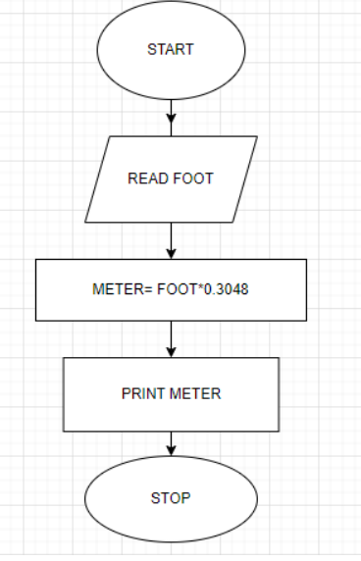
PROGRAM: | #include<stdio.h>  int main()  {  float foot,meter;  printf("Enter foot : ");  scanf("%f",&foot);  meter = foot/0.3048;  printf("The Foot in Meter is %.3f",meter);  return 0;  }
RESULT: 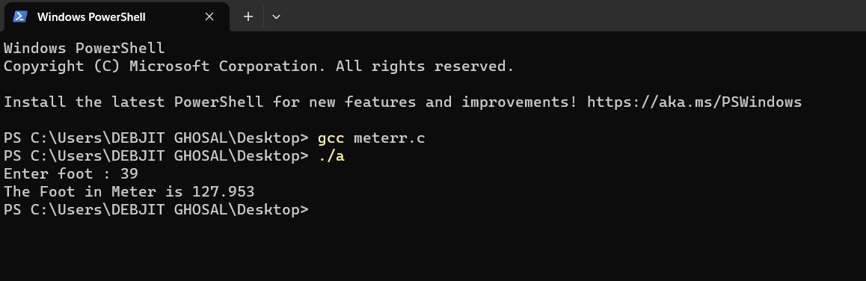
Program 4
PROBLEM STATEMENT: | Write a C program to convert days into year, month and days.
ALGORITHM: | Step1:Start  Step2:Read days,years,months,weeks,rdays  Step3: using the formula years=(days/365),months=(days-years*365)/30,  weeks=(days%365%30)/7,rdays=days-(years*365)-(months*30)-(weeks*7)  Step4: display in years,months,weeks,rdays  Step5: Stop
FLOWCHART: | 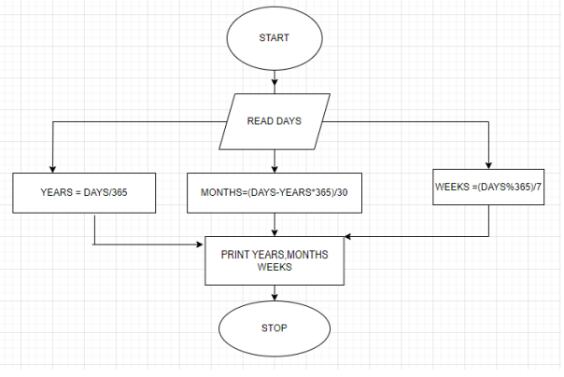
PROGRAM: | #include <stdio.h>  int main(){  int days,years,months,weeks,rdays;  printf("Enter the Days :");  scanf("%d",&days);  years=(days/365);  months=(days-years*365)/30;  weeks=(days%365%30)/7;  rdays= days-(years*365)-(months*30)-(weeks*7);  printf("%d years,%d months,%d weeks,%d rdays",years,months,weeks,rdays);  return 0;  }
RESULT: 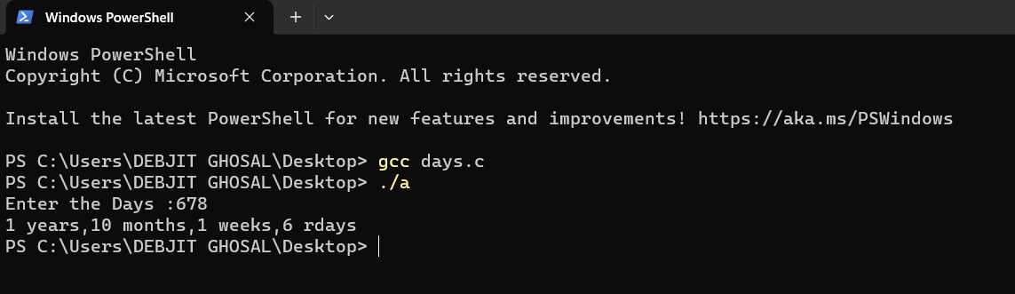
Program 5
PROBLEM STATEMENT:
ALGORITHM:
FLOWCHART:
PROGRAM:
RESULT:
CONCLUSION:

